**Two Days Workshop on “Essentials of Patent Search, Drafting & Filing Procedures”**

**Name and designation of the Guest Speakers/ Judges/ Mentors etc.:**

1. Mrs. Kawita Kanoje; Co-founder, PATHtoIP®
2. Mrs. Nidhi Agrawal, Co-founder, PATHtoIP®
3. Dr. Sanjay Sharma, Associate Professor, SVKM's NMIMS, SPPSPTM, Mumbai

**Venue:** Wing-C, 2nd Floor, Conference Hall-3, MPTP, Shirpur Campus

**Start Date:** **14th Sep,** 2024

**End Date: 15th Sep,** 2024

**Time:** 10:00 am –05:00 PM on **14th Sep,** 2024; 10:00 AM–3:00 PM on **15th Sep,** 2024.

**Duration of the activity (in Hrs):** 12 hours

**Link of social media post of e-pamphlet:**

**Link for social media post of video:**

**Program Type:** Two Days Workshop on “Essentials of Patent Search, Drafting & Filing Procedures”

**Objective of the activity (100 characters):**

The primary objective of this workshop was to enhance the understanding and practical skills of participants in the critical aspects of intellectual property rights (IPR), specifically focusing on patent search, drafting, and filing procedures. The workshop aimed to equip participants with the knowledge required to navigate the patenting process effectively, ensuring that innovations are legally protected. By providing in-depth sessions on prior art searches, patent drafting, and the overall patent filing process, the workshop sought to foster an environment of innovation and legal awareness among professionals in the fields of pharmacy, engineering, and agriculture, thereby contributing to the commercialization of research outputs.

**Benefit in terms of learning, skills, knowledge obtained (150 characters):**

The workshop provided participants with essential knowledge and skills in intellectual property rights (IPR), focusing on patent search, drafting, and filing. Through hands-on training, they learned to conduct prior art searches, draft patent claims, and navigate the patent filing process. The sessions enhanced their understanding of the strategic role of IPR in various sectors and the importance of protecting innovations. Participants left with a stronger ability to safeguard and commercialize their intellectual contributions effectively.

**SVKM's NMIMS Faculty Coordinators for the activity:**

1. Dr. Shashikant B Bagade, Associate Professor, SPTM

2. Dr. Amit B. Page, Assistant Professor, SPTM

3. Dr. Vishal Gokul Beldar, Assistant Professor, SPTM

**SVKM's NMIMS Student Coordinators for the activity:**

**Number of student participants:** 170 participants participated in the event, out of which 14 were external participants and 156 were internal participants.

**Number of faculty participants:** 25 Faculties (Internal), 1 External

**Number of External Participants, if any:** 14 participants.

**Expenditure Amount, if any:**

**Mode of session delivery:** Offline

**Background of the speakers / Judges / Mentors etc. (Brief Resume):**

**Mrs. Kawita Kanoje:** Kawita Kanoje brings a wealth of experience in intellectual property, with a specialization in building comprehensive and exhaustive search strategies for Prior Art Search, Novelty & Patentability, Technology Landscapes, FTO analysis, Invalidation, and more. Her multidisciplinary expertise spans synthetic & organic chemistry, polymers, FMCG formulation, packaging, medicine, medical devices, and sustainable solutions (bio-based). Kawita is dedicated to empowering inventors, technologists, start-ups, and companies by helping them secure IP protection, thus driving R&D activities and fostering business growth.

**Mrs. Nidhi Agrawal:** Nidhi Agrawal's rich experience in research and intellectual property has made her a trusted consultant for startups, MNCs, and various other companies. Her expertise encompasses IP searching & analysis, patent drafting, filing, and prosecution. Nidhi excels at navigating complex IP cases and is passionate about protecting technical inventions across diverse domains, including chemistry, pharma, life sciences, and engineering, ensuring her clients can innovate with confidence.

**Dr. Sanjay Sharma**: Dr. Sanjay Sharma, with over 22 years of experience in research, academics, and industry, is an Associate Professor and Head of Quality Assurance at NMIMS University, Mumbai. He holds a Ph.D. in Pharmaceutical Sciences, has 15 patents, over 120 publications, and has guided multiple Ph.D. and PG students. Dr. Sharma specializes in advanced analytical methods and has received awards for research excellence. He is a life member of several professional societies and has organized national workshops on pharmaceutical quality control.

**Report on the session with the key outcomes (1-2 pages):**

On 14th of September SVKM’s NMIMS SPTM held an event based on “Essentials of Patent Search, Drafting & Filing Procedures” IPR (intellectual property rights) under Institutional Innovation Council (IIC) in collaboration with SOBUS. In this two-day workshop sessions, a lot of information gained by the participants related to patent, intellectual property and finding and filling procedures of the patent etc. The event highlighted the significance of IPR in various sectors, including pharmacy, engineering, and agriculture, and explored the relationship between innovation and legal protection.

Dr. Sunita R. Patil , Director MPTP and President IIC, MPTP Shirpur opened the session with ceremonial address with a focus on the importance of innovation. She noted that China leads globally in patent filings, underscoring the critical role of IPR in converting research breakthroughs into commercially viable products. She emphasized the collaborative efforts of the private sector, public institutions, and government bodies in supporting and regulating intellectual property.

Dr. Shyam Sunder Pancholi, Associate Dean of SPTM and Vice-President of IIC at MPTP Shirpur Campus, delivered the keynote address

Dr. Shashikant B Bagade, Coordinator of the IPR-Cell at IIC MPTP, provided an overview of the workshop.

Mrs. Kawita Kanoje provided an in-depth overview of IP and IPR, explaining that IP includes creations of the mind such as inventions, literary and artistic works, and designs, while IPR offers legal rights to protect these creations. She illustrated various types of IP, including trademarks (e.g., Nike, Audi), geographical indications (e.g., Darjeeling tea), and patents (e.g., innovative fabrics). Dr. Kanoje highlighted how brands like Coca-Cola use trade secrets to protect their formulas and designs.

Mrs. Nidhi Agrawal discussed the essentials of prior art search, a critical component in the patenting process. She explained that prior art encompasses existing knowledge relevant to new inventions and includes patents, scientific publications, and even non-traditional sources like YouTube videos. The search helps determine the novelty and viability of innovations and prevents infringement. Dr. Agrawal detailed the different types of prior art searches, including patentability, freedom to operate, and technology landscape searches, and emphasized the value of these searches in avoiding legal disputes and strategic planning.

During this session most of the M.Pharm +MBA Second year students has performed prior art search for their running project and understood the sequence. The response of participants from engineering, pharmacy, and agriculture background was overwhelming.

On Day-2 Dr. Sanjay Sharma delivered a comprehensive session on patent drafting, guiding participants through the essential elements of securing intellectual property rights. The session covered a wide array of topics with understanding and navigating the patent process. Dr. Sharma's presentation began with an overview of the fundamental concepts of patent drafting, focusing on the types of claims. Participants were introduced to the importance of prior art searches, which are essential for assessing the novelty of an invention and determining its patentability.

A key highlight of the workshop was the explanation of the core components of a patent, including the significance of the patent's name and its definition. He emphasized how a well-defined patent name contributes to exclusivity and the strategic timing for filing patents. He also highlighted the critical "first to file" rule, contrasting it with the outdated "first to invent" principle.

The hands-on training on patent drafting (claim drafting) provided an in-depth look at patent drafting issues. He outlined the key elements of drafting a patent, including provisional patent content, complete patent specifications, and the associated costs. Participants gained practical experience in drafting and refining patent claims, which are crucial for establishing the scope of protection offered by a patent.

The workshop also addressed practical aspects of patent filing, such as drafting patent specifications, navigating the application process, and understanding essential forms and procedures. Participants were informed about the steps involved, from conducting prior art searches to commercialization of patents.

The learning evaluation quiz conducted just after the hands on session and participants submitted their quiz with the inclusion of patent claims drafted during the hands on session.

In this quiz the PG student, UG student, and Faculty members have submitted the answers to the questions.

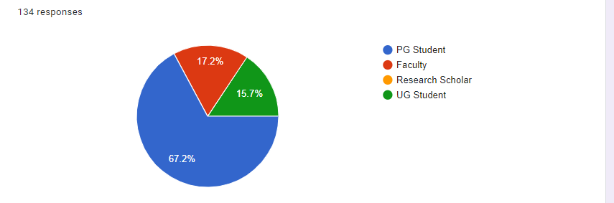The event concluded with a ceremonial address by Pancholi Sir, who highlighted the workshop’s success in enriching attendees' understanding of IP and its role in science and technology.

This event is coordinated by Dr. Shashikant Bagade, Associate professor and section head QA, In charge IPR-Cell with Dr. Amit B. Page, Section head Pharm Tech and Dr. Vishal Beldar, Assistant Professor, SPTM Shirpur.

Overall, the workshop covered the indispensable role of IPR in innovation and ensuring that research contributions are legally protected. The event served as a valuable resource for understanding the complexities of IP and its impact on various sectors.

**Glimpses of the event (4 photographs):**

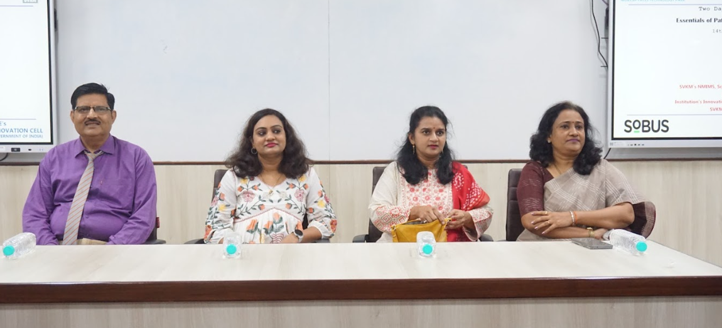

**Dignitaries along with the session speakers**

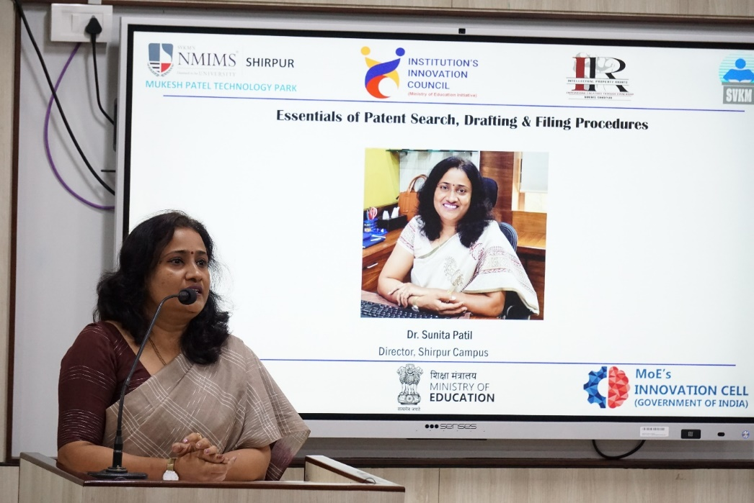

**Ceremonial address by Dr. Sunita R. Patil, Director MPTP and President IIC, MPTP Shirpur**

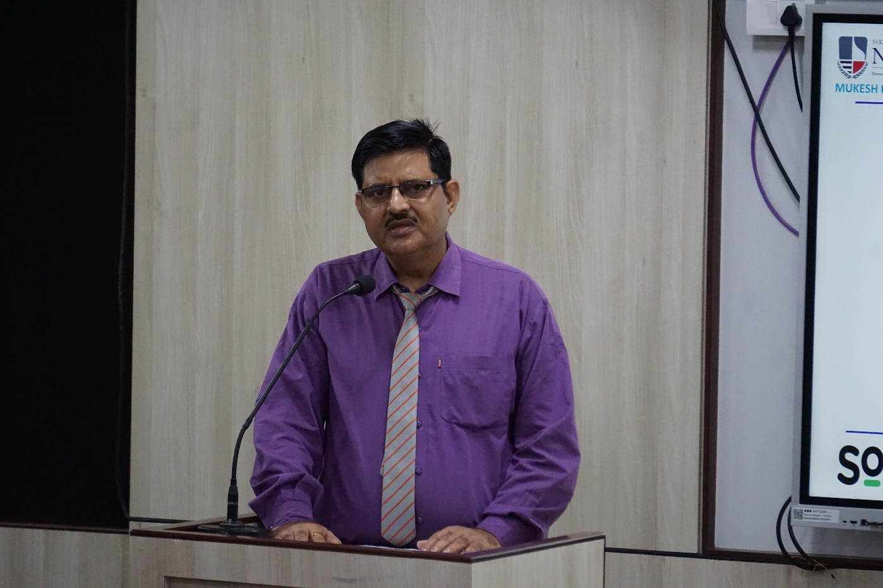

**Keynote address by Dr. Shyam Sunder Pancholi, Associate Dean, SPTM & Vice-President IIC, MPTP Shirpur Campus**

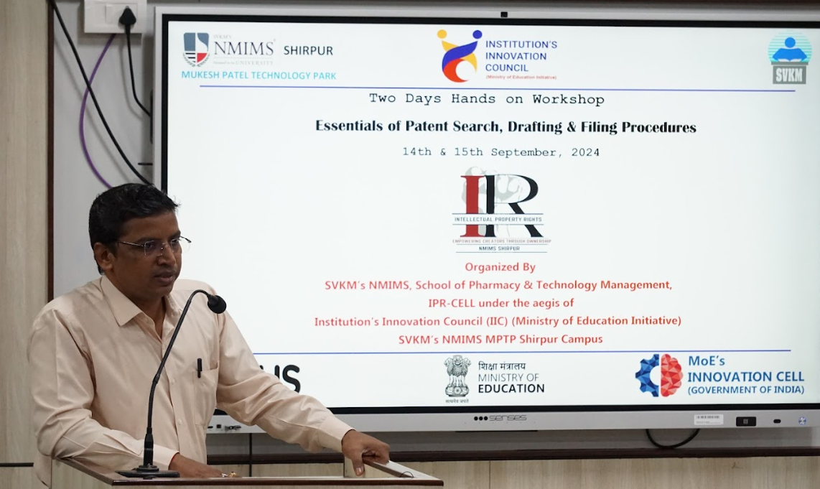

**Workshop overview by Dr. Shashikant B Bagade, Coordinator, IPR-Cell IIC MPTP**

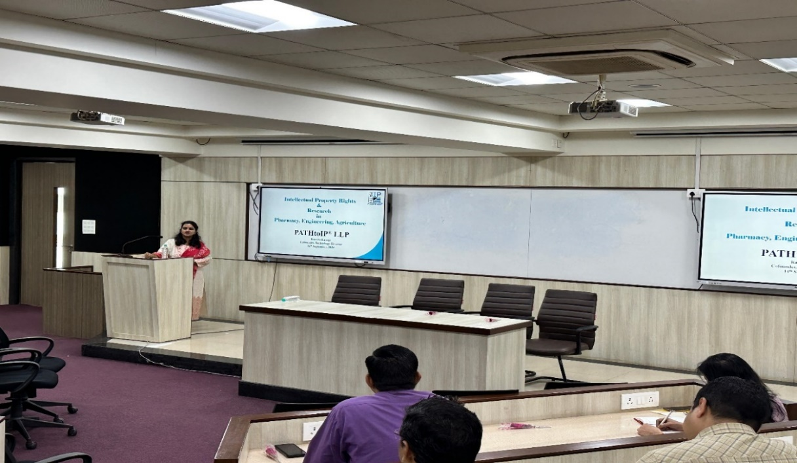

**First session on IPR & Research in Pharmacy, Engineering & Agriculture by Ms. Kawita Kanoje, PathtoIP, Pune (Day I)**

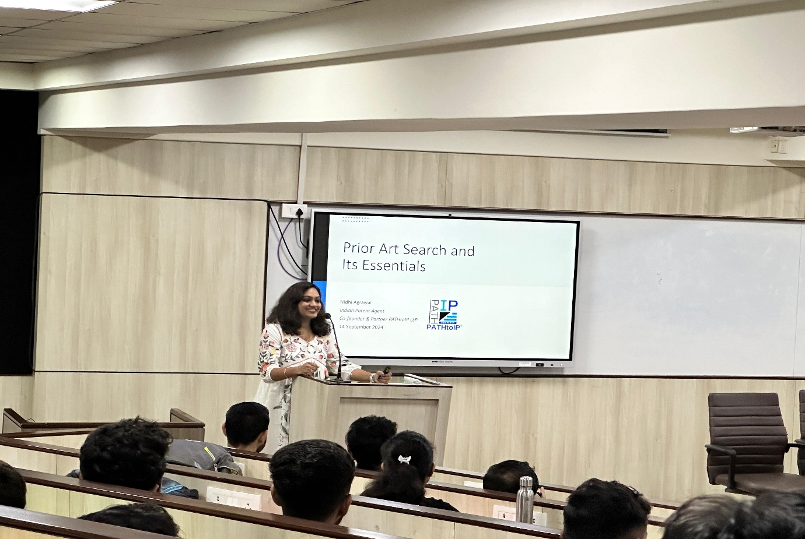

**Second session on Prior art search and its essentials by Mrs.Nidhi Agrawal, PathtoIP, Pune (Day I)**

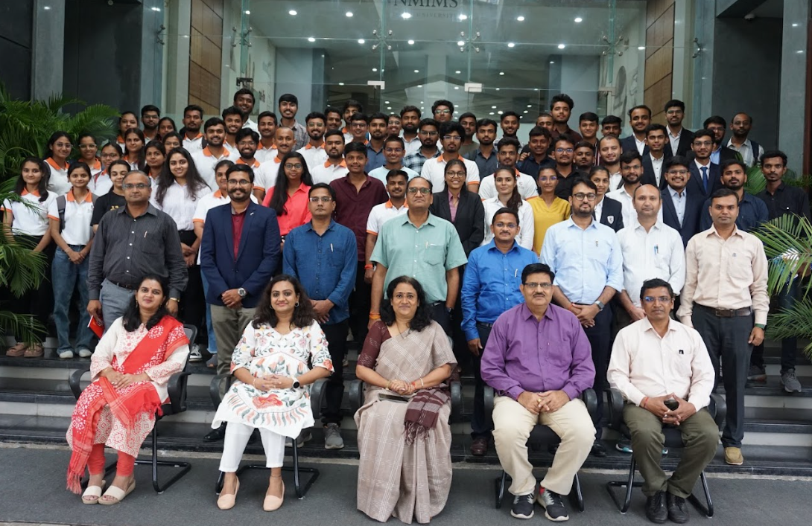

**Group Photo Session with Participants (Day-I)**

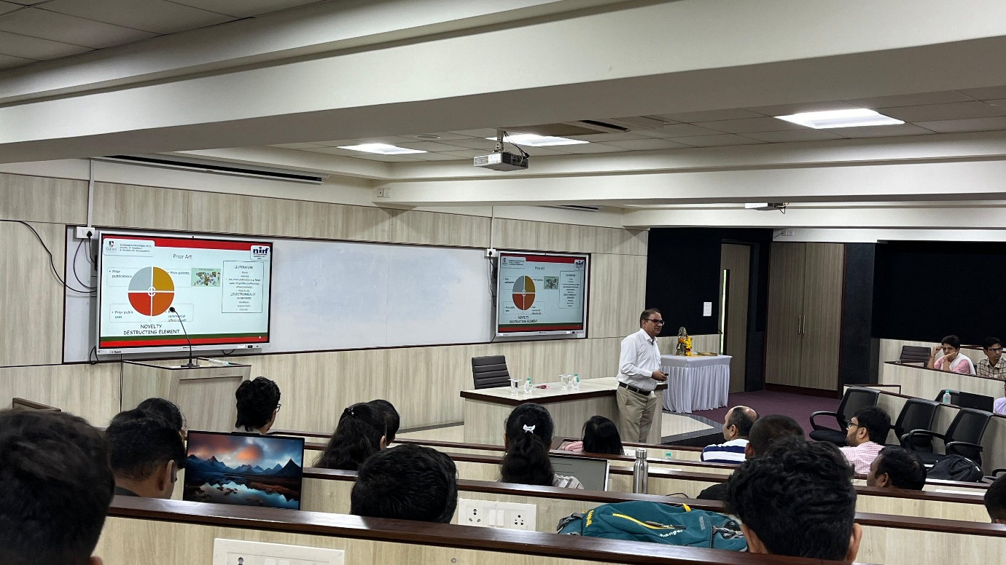

**First session on Patent drafting by Dr. S. S. Sharma (Day II)**

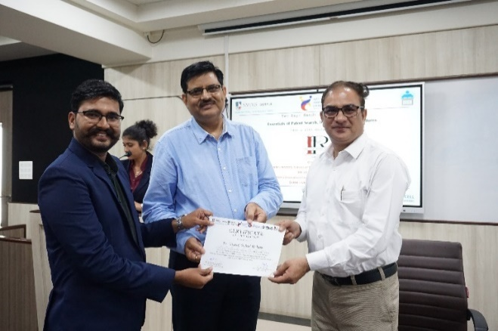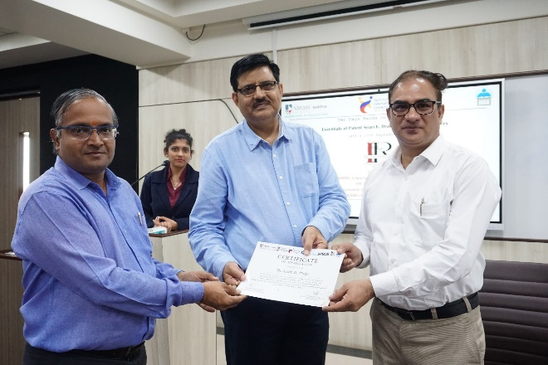

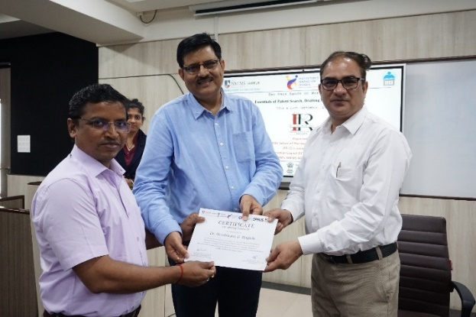

**Felicitation of the Workshop Co-ordinator at the Hands of Dr.S .S. Pancholi**

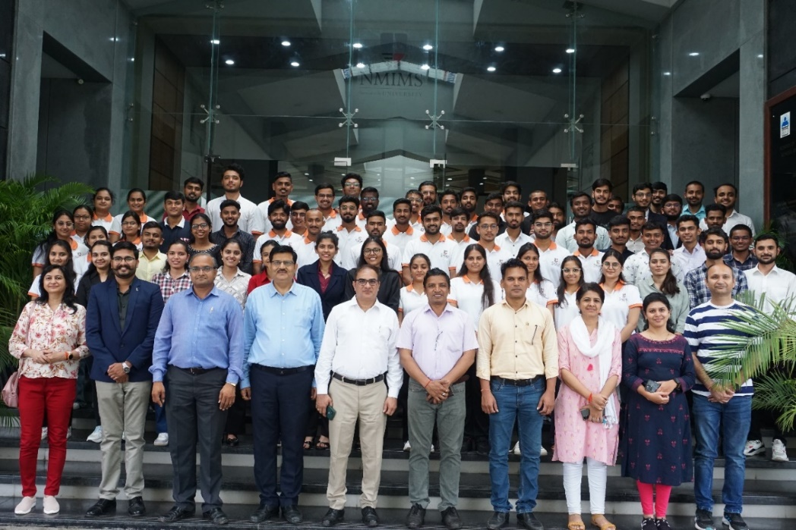

**Group Photo Session with Participants (Day-II)**