

**Mukesh Patel School of Technology Management & Engineering, Shirpur**

**Academic Year: 2024-2025**

Report on

**App Development Club’s Event**



**Mukesh Patel School of Technology Management and Engineering, Shirpur**

**Academic year (2024-25)**

**ACTIVITY REPORT**

## “Appify”

**Objective**: ADC organized its first event, "Appify " on September 25, 2024. The event aimed to raise awareness among students about ADC's past initiatives and future projects.

**Organizer: App Development Club**

**Number of Participant: 120 (First Year)**

**Speaker:** Mr. Meet Maheswari(Student)

Mr. Owais Fahim(Student)

**Date & Day**: **25/09/2024**

**Time & Venue**: 05:00PM - 06:30PM, Auditorium C-Wing 2nd floor

**Permission/Notice:**

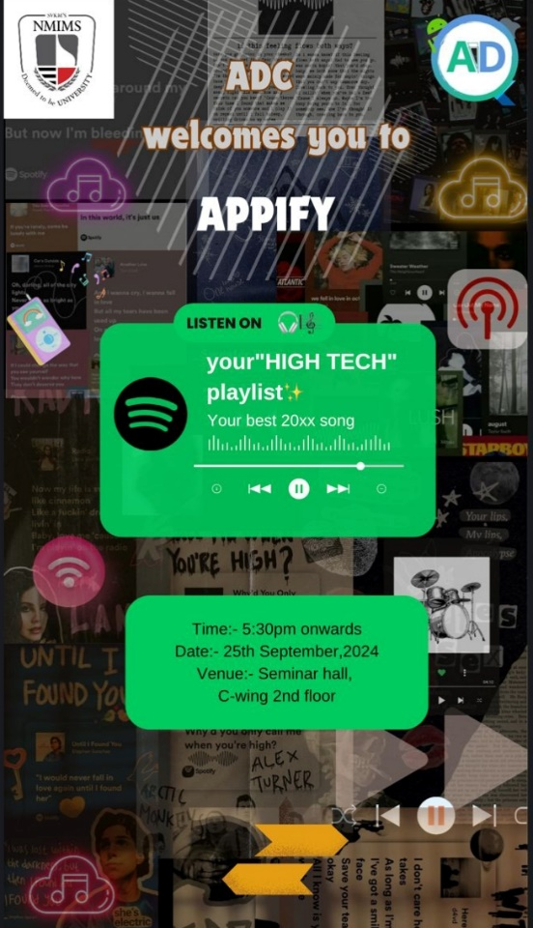

**Coordinator/s:**

|  |  |  |  |  |
| --- | --- | --- | --- | --- |
| **Name** | **Programme** | **Year** | **Branch** | **Role Assigned** |
| Pragya Maheshwari | B Tech | 3rd | CS | Head |
| Amit Upadhyay | B Tech | 3rd | CS | Co-Head |
| Utkarsh Mandloi | B Tech | 3rd | CS | Core Member |
| Ronak Vishanwani | B Tech | 2nd | CS | Core Member |
| Navya Singh | B Tech | 2nd | AIML | Core Member |
| Aastha Tiwari | B Tech | 3rd | AIML | Core Member |
| Rushikesh Patil | B Tech | 3rd | CE | Core Member |
| Swet Singh | B Tech | 3rd | CS | Core Member |
| Garima Nandwani | B Tech | 3rd | CS | Core Member |
| Sakina Kayyawala | B Tech | 2nd | AIML | Core Member |
| Yashasvee Wankhede | B Tech | 2nd | CS | Core Member |

**Name of teaching staff:** Prof. Dhiraj Bhise

**Brief Report on Activity:**

ADC organised its first event “Appify” on 25th September 2024. The event was mainly focused on making people aware about ADC’s past and future work and events. There were also entertaining fillers and acts to keep the audience engaged.

**Introduction and Welcome**

The event began with a warm welcome from Navya and Aastha, who introduced the App Development Club (ADC)

**Agendas, Outcomes and Objectives of ADC**

Owais Sir and Meet Sir, the club heads, were introduced to the audience by Aastha, followed by an overview of the ADC's past achievements and future goals. She provided an overview of the ADC's past accomplishments and outlined the club's future goals and aspirations, inspiring attendees with the exciting prospects ahead.

**Filler 1: Tune Ka Tadka**

The audience was divided into four teams named after popular singers: Arijit Singh, Shreya Ghoshal, Taylor Swift, and The Weekend. Each team participated in the musical quiz, "Tune Ka Tadka," where they had to identify songs from their first 5 seconds.

The quiz featured a series of popular songs including: Liggi, Millionaire, Tari Madh Mithi Baate, Mehbooba, Masakali, Aaoge Tum Kabhi, Chogada

The Weekend team emerged as the winner of the musical quiz.

**Past and Upcoming Events**

A recap of previous ADC events, such as Flutter Flight, Chatbot Bootcamp, Bollywood Apps Meme (BAM), and A.R. Workshop, was presented. Upcoming events like BAM 2.0, App Venture, GitHub Workshop, LR Workshops, and other Workshops were also announced.

**Filler Act: ADC Ka Khulasa**

A fun and engaging filler act, "ADC Ka Khulasa,", a satire about what actually goes on during ADC OC meets, was performed by a group of ADC Event Management members who enacted as the core members of club, adding a touch of entertainment to the event. In this filler, Krish acted as Meet, Pranav as Owais, Reshma as Aastha, Nishtha as herself, Prajusha as Rushikesh, Suhani as Sakina, Devyani as Malay, Mitali as Yashasvee, Preet as Navya, Tanay as Ronak and Aditya as Rehan and Prakhar as Jenish.

**Surprise Music Performance and Event Conclusion**

The event concluded with a surprise musical performance by Aryan, Sharvin, and Sujal, leaving the audience entertained and impressed.

Overall, the Appify event was a successful gathering that showcased the talents of ADC members, fostered teamwork, and provided a platform for networking and learning. It highlighted the extraordinary abilities and inventiveness of ADC members, and offered a useful forum for networking and education.

**Mapping POs and PEOs to the Event:**

* **Program Outcomes (POs):**
  + **PO1:** Engineering Knowledge: Understanding the fundamentals of Flutter in app development.
  + **PO2:** Problem Analysis: Identifying and defining problems that can be solved using mobile apps.
* **Program Educational Objectives (PEOs):**
  + **PEO1:** Preparation: Preparing students for successful careers in app development.
  + **PEO3:** Professionalism: Encouraging creativity and innovation through interactive sessions.

# PSO1 will be addressed as this event talks about the overall development of students

PEO2: To produce graduates who function effectively in a multi-disciplinary environment and individually within a societal and environmental context.

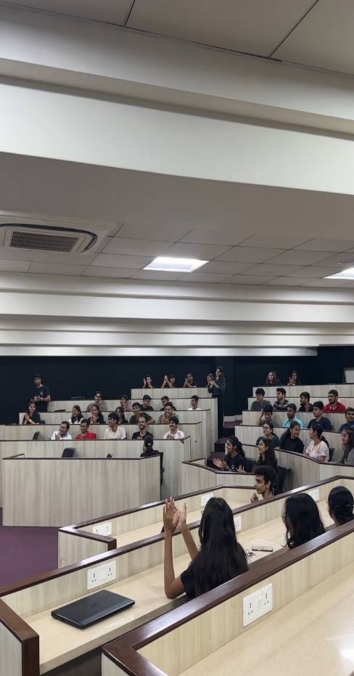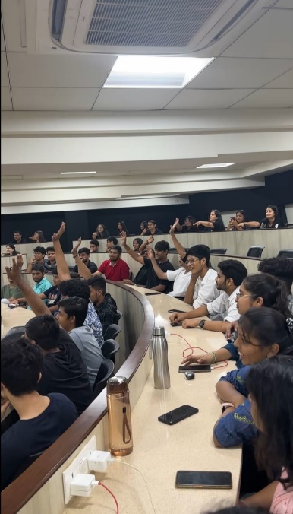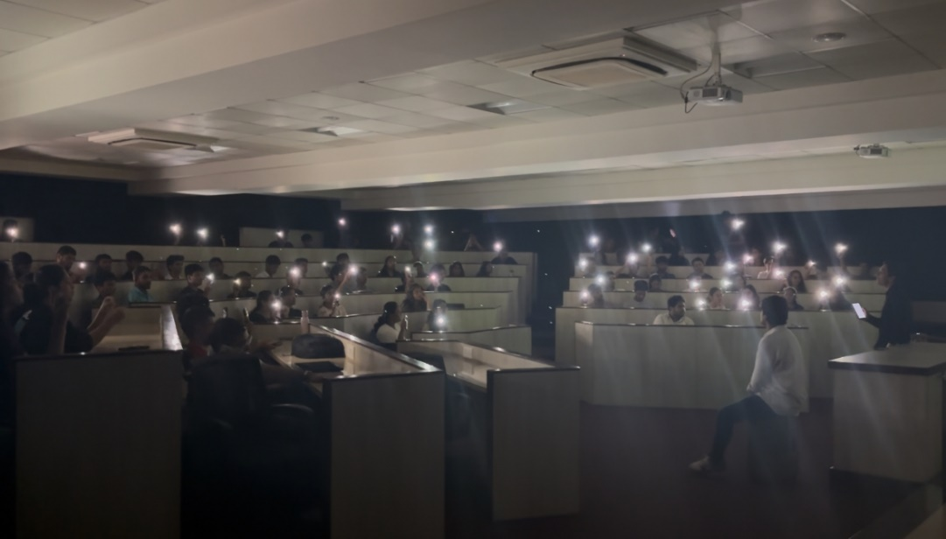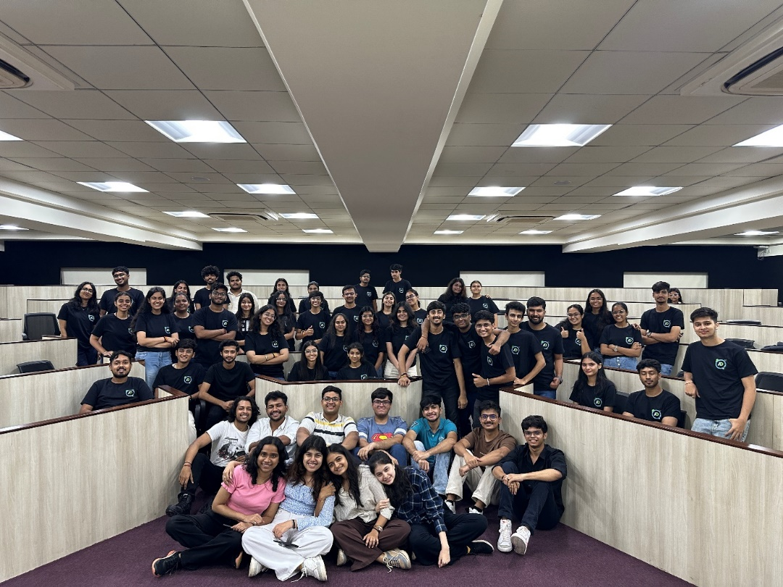**Event Photographs:**

Event In-charge

**Mukesh Patel School of Technology Management and Engineering, Shirpur**

Academic year (2024-25)

**Attendance Report**

**Date & Day**: **25/09/2024**

**Time & Venue**: 05:00PM - 06:30PM, Auditorium C-Wing 2nd floor

**Number of Participant: 120 (First Year)**

|  |  |  |  |  |
| --- | --- | --- | --- | --- |
|  | **Program** | **Sem** | **Student_Name** | **Sign** |
|  | BTech CS | II Sem | AYUSHI JOSHI |  |
|  | BTech CS | II Sem | MOHD. YUSUF KHAN |  |
|  | BTech CS | II Sem | AKSHAT KATIYAR |  |
|  | BTech CS | II Sem | MANVI JADHAV |  |
|  | BTech CS | II Sem | AASTHA DARJI |  |
|  | BTech CS | II Sem | SHAMBHAVI SINGH |  |
|  | BTech CS | II Sem | PUSHP JAIN |  |
|  | BTech CS | II Sem | PRIYANSHU TIWARI |  |
|  | BTech CS | II Sem | DAKSH LALAWAT |  |
|  | BTech CS | II Sem | MOHAMMED SHADMAN |  |
|  | BTech CS | II Sem | PARUL MAHESHWARI |  |
|  | BTech CS | II Sem | TUSHAR BORASE |  |
|  | BTech CS | II Sem | AAYUSHI SHIROLE |  |
|  | BTech CS | II Sem | JASH PANCHAL |  |
|  | BTech CS | II Sem | SAMBHAV JAIN |  |
|  | BTech CS | II Sem | ATHARVA CHAUDHARI |  |
|  | BTech CS | II Sem | NEHA CHHIPA |  |
|  | BTech CS | II Sem | BISWAJEET ROUT |  |
|  | BTech CS | II Sem | MAHEK AGARWAL |  |
|  | BTech CS | II Sem | PARTH BHOI |  |
|  | BTech CS | II Sem | SUYASH JAIN |  |
|  | BTech CS | II Sem | SPARSHIKA MALI |  |
|  | BTech CS | II Sem | ASHMITA MAZUMDAR |  |
|  | BTech CS | II Sem | SAKSHAM HEDAOO |  |
|  | BTech CS | II Sem | PURVA MORE |  |
|  | BTech CS | II Sem | ADARSH SINGH |  |
|  | BTech CS | II Sem | SHUBHAM PATIL |  |
|  | BTech CS | II Sem | MEGHASHYAM PAWAR |  |
|  | BTech CS | II Sem | NIKHIL PAWAR |  |
|  | BTech CS | II Sem | VARAD BHAMARE |  |
|  | BTech CS | II Sem | PARTH KANADE |  |
|  | BTech CS | II Sem | MOKSH AMIT SHAH |  |
|  | BTech CS | II Sem | AARYAN INGLE |  |
|  | BTech CS | II Sem | YUG AGRAWAL |  |
|  | BTech CS | II Sem | MANASVI BHARDWAJ |  |
|  | BTech CS | II Sem | KUSHAL KHADSE |  |
|  | BTech CS | II Sem | PIYUSH NAVALKAR |  |
|  | BTech CS | II Sem | SHREYANSH RATHOR |  |
|  | BTech CS | II Sem | SNEHA JHANWAR |  |
|  | BTech CS | II Sem | CHINMAI PATIL |  |
|  | BTech CS | II Sem | AMISHKA VIJAY |  |
|  | BTech CS | II Sem | ADITYA CHAVAN |  |
|  | BTech CS | II Sem | KESHAV YADAV |  |
|  | BTech CS | II Sem | SHRADDHA GAUD |  |
|  | BTech CS | II Sem | KALYANI PATIL |  |
|  | BTech CS | II Sem | SARTHAK JAIN |  |
|  | BTech CS | II Sem | HEMANGI INGALE |  |
|  | BTech CS | II Sem | MANTHAN PATIL |  |
|  | BTech CS | II Sem | SHREYA DESAI |  |
|  | BTech CS | II Sem | DEVAYANI HEKARE |  |
|  | BTech CS | II Sem | RASHI KHODRE |  |
|  | BTech CS | II Sem | ANUSHKA RAGHUWANSHI |  |
|  | BTech CS | II Sem | RAVIRAJ JIGE |  |
|  | BTech CS | II Sem | KUSHAGRA PANDEY |  |
|  | BTech CS | II Sem | YASH BHARDWAJ |  |
|  | BTech CS | II Sem | OM THAMKE |  |
|  | BTech CS | II Sem | PRATIK SONAWANE |  |
|  | BTech CS | II Sem | ADITYA DAHITE |  |
|  | BTech CS | II Sem | SHOURYA LOHAR |  |
|  | BTech CS | II Sem | GAURAV PATIL |  |
|  | BTech CS | II Sem | MEET JAIN |  |
|  | BTech CS | II Sem | SHRADDHA GANGURDE |  |
|  | BTech CS | II Sem | MOHIT SUNDAL |  |
|  | BTech IT | II Sem | GAYATRI WAGH |  |
|  | BTech IT | II Sem | ILSA KHAN |  |
|  | BTech IT | II Sem | VEDIKA CHANDANI |  |
|  | BTech IT | II Sem | GUNJAN LALWANI |  |
|  | BTech IT | II Sem | NILESH PATIL |  |
|  | BTech IT | II Sem | MANROOP SINGH BHOGAL |  |
|  | BTech IT | II Sem | NACHIKET BHADANE |  |
|  | BTech IT | II Sem | PRASENJIT. KHARE. |  |
|  | BTech IT | II Sem | YUVRAJ DHANRAJ KALE |  |
|  | BTech IT | II Sem | DNYANESH MAGARE |  |
|  | BTech IT | II Sem | YOGESHWARI BHOI |  |
|  | BTech IT | II Sem | SAMIKSHA JAIN |  |
|  | BTech IT | II Sem | ARYAN RAGHUWANSHI |  |
|  | BTech IT | II Sem | HARSHWARDHAN WAGH |  |
|  | BTech IT | II Sem | MEHI MANSWA BHAGAT |  |
|  | BTech IT | II Sem | VAIBHAV RAGHUVANSHI |  |
|  | BTech IT | II Sem | SOMMYA GUPTA |  |
|  | BTech IT | II Sem | DHRUVIT PATEL |  |
|  | BTech IT | II Sem | BILAL HAIDRY |  |
|  | BTech IT | II Sem | RISHIKESH BORUDE |  |
|  | BTech IT | II Sem | SARTHAK SALOT |  |
|  | BTech IT | II Sem | MAYURI BHAMARE |  |
|  | BTech IT | II Sem | PRACHIT SHINDE |  |
|  | BTech IT | II Sem | ADIVYA KUMAR SINGH |  |
|  | BTech IT | II Sem | LOKESH PATIL |  |
|  | BTech IT | II Sem | SAKSHI HOLANKAR |  |
|  | BTech IT | II Sem | RIYA CHAUDHARI |  |
|  | BTech IT | II Sem | SHARVA PARAG SHENOY |  |
|  | BTech IT | II Sem | VEDANSH KANUNGO |  |
|  | BTech IT | II Sem | YASH DEORE |  |
|  | BTech IT | II Sem | SALIL SAMPAT |  |
|  | BTech IT | II Sem | POOJA NAIK |  |
|  | BTech IT | II Sem | YASH DHARAMPURIA |  |
|  | BTech IT | II Sem | KALYANI SUNIL PATIL |  |
|  | BTech IT | II Sem | PRERNA PATIL |  |
|  | BTech IT | II Sem | PIYUSH CHAUDHARI |  |
|  | BTech IT | II Sem | UMESH MORE. |  |
|  | BTech IT | II Sem | SALONI GIRASE |  |
|  | BTech IT | II Sem | MANDAN LAHER |  |
|  | BTech IT | II Sem | SAKSHI NAHAR |  |
|  | BTech IT | II Sem | GAURAV CHAUDHARI |  |
|  | BTech IT | II Sem | KHYATI PATIL |  |
|  | BTech IT | II Sem | HARSHAL RAJPUT |  |
|  | BTech IT | II Sem | BHUMIKA CHAVAN |  |
|  | BTech IT | II Sem | SANKET PATIL |  |
|  | BTech IT | II Sem | SAKET MORE |  |
|  | BTech IT | II Sem | SHRAVANI YOGESH KOTHAWADE |  |
|  | BTech IT | II Sem | VIRAJ PAWAR |  |
|  | BTech IT | II Sem | NAKSHATRA PALIWAL |  |
|  | BTech IT | II Sem | TANISHKA BHOIR |  |
|  | BTech IT | II Sem | ADITYA AGRAWAL |  |
|  | BTech IT | II Sem | CHINMAYA CHAMEDIA |  |
|  | BTech IT | II Sem | ANANYA SINHA |  |
|  | BTech IT | II Sem | AARAV DUBEY |  |
|  | BTech IT | II Sem | NAMAY MANCHANDA |  |
|  | BTech IT | II Sem | KRUPA PATIL |  |
|  | BTech AIML | II Sem | TIWARI, YASH |  |

Event In-charge

Asst. Prof. Dhiraj Bhise