

**Mukesh Patel School of Technology Management & Engineering, Shirpur**

**Academic Year: 2024-2025**

**Report on**

**App Development Club’s Event**



**Mukesh Patel School of Technology Management and Engineering, Shirpur**

**Academic year (2024-25)**

**ACTIVITY REPORT**

“AR Workshop”

The AR Workshop, organized by the App Development Club (ADC) in collaboration with Ambiora’25, was an engaging and highly interactive session designed to introduce participants to the world of Augmented Reality (AR). The workshop took place on 01/03/25, starting at 10:00 AM, with attendees arriving well-prepared with pre-installed Unity Hubs.

**Organizer: App Development Club**

**Number of Participant: 52**

**Speaker: Mr. Priyam Sekra (Student)  
 Mr. Vipul Bhatia (Student)**

**Date & Day**: **01/03/2025 Tuesday**

**Time & Venue**: 10 am – 1 pm (CC-1 Lab B Wing 1st Floor)

**Permission/Flyer/Notice:**

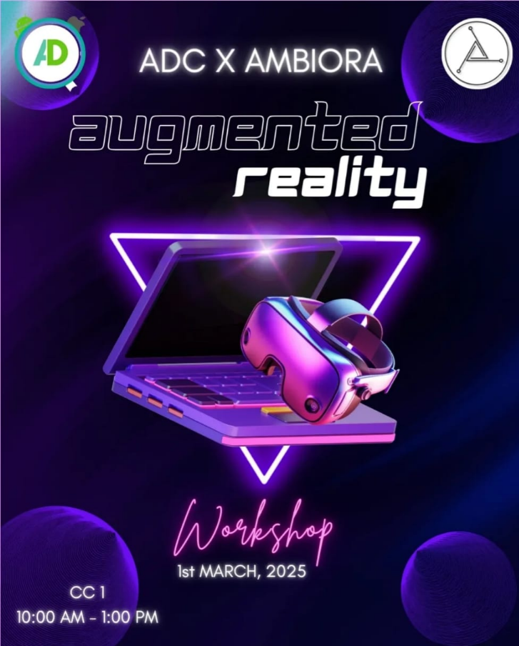

|  |  |  |
| --- | --- | --- |
| **Sr. No.** | **Position** | **Student Name** |
| 1 | Club Leads | Meet Maheshwari Owais Bubere |
| 2 | Marketing Head | Ronak Vishanwani Jenish Mehta |
| 3 | Creative Leads | Malay Padshah Rushikesh Patil |
| 4 | Event Management Leads | Aastha Tiwari Navya Singh |
| 5 | Technical Leads | Rehan Singhal Sakina Kayya |
| 6 | PR and Documentation | Yashasvee Wankhade |

**Name of Teaching staff:** Prof. Dhiraj Bhise

**Brief Report on Activity:**

**Session Overview**

The workshop was conducted by Mr. Vipul and Mr. Priyam, 4th-year MBA Tech students from NMIMS, who have significant experience in the AR/VR domain. The session aimed to provide hands-on experience in AR development.

The workshop began with an introduction to AR and VR, covering:

- The future of AR and VR

- Differences between AR and VR

- Types of AR, including superimposition, marker-based, and marker-less AR

- Applications of AR in e-commerce, with examples like Lenskart, Amazon, and Pokémon GO, illustrating how AR bridges the gap between digital and physical environments.

**Technical Walkthrough:-**

The second part of the session focused on Unity, a popular game development platform used for AR and VR applications. Key takeaways included:

- Best practices in tech development, such as using the same project name consistently.

- Creating a new Unity project, understanding the sample scene, and placing objects within it.

- Explanation of the 3D coordinate system (X, Y, Z axes) and the Inspector panel for modifying object properties like light and camera settings.

- Importance of Transform properties (scale, position, rotation) in defining objects.

- Removing the Main Camera to observe the effect on rendering.

**Hands-on with Vuforia:-**

To implement AR, participants were introduced to Vuforia, a widely used AR development engine. The process involved:

1. Visiting developer.vuforia.com, signing in, and downloading Vuforia Engine 11 for Unity.

2. Adding an Image Target with a high augmentability rating (4-star or above) to ensure better tracking.

3. Importing the downloaded database into Unity.

4. Placing an AR Camera in the scene with the following position and rotation values:

   - Position: X = 0, Y = 9.44, Z = 0

   - Rotation: (55, 0, 0)

5. Adding a sphere to the Image Target and defining its dimensions as (1,1,1).

6. Running the simulation to display the animated sphere floating in the air, showcasing successful AR implementation.

**Interactive Segment**

To maintain engagement, students conducted a fun filler activity called "Dialogues ka Dumb charades."

- OC members picked chits with famous dialogues and acted them out while the audience guessed.

- A 45-second timer was set for each performance, making the game lively and entertaining.

**Conclusion**

The AR/VR Workshop was a resounding success, providing attendees with practical exposure to AR development using Unity and Vuforia. The session was well-structured, engaging, and avoided monotony by incorporating hands-on guidance and interactive activities. Participants gained valuable insights into AR applications, technical implementation, and best practices in Unity development, leaving them with a strong foundation to explore the AR/VR domain further.

**Mapping POs and PEOs to the Event:**

* **Program Outcomes (POs):**
  + **PO1:** Engineering Knowledge: Understanding the fundamentals of Flutter in app development.
  + **PO2:** Problem Analysis: Identifying and defining problems that can be solved using mobile apps.
* **Program Educational Objectives (PEOs):**
  + **PEO1:** Preparation: Preparing students for successful careers in app development.
  + **PEO3:** Professionalism: Encouraging creativity and innovation through interactive sessions.

# PSO1 will be addressed as this event talks about the overall development of students

**Mukesh Patel School of Technology Management and Engineering, Shirpur**

**Attendance Report**

Academic year (2024-25)

Event: “AR Workshop”

Organizer: App Development Club

Date: 01/03/2025

Time & Venue: 10 am – 1 pm CC1 Lab B wing 2nd Floor

Number of Participant: 52

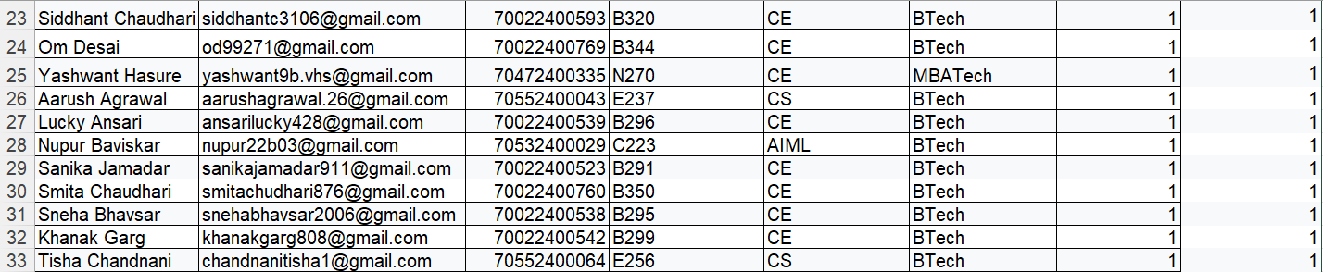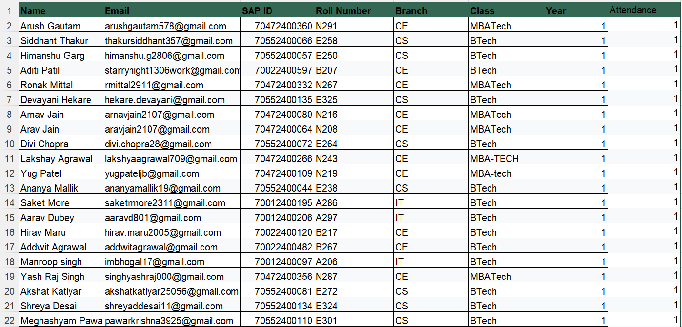

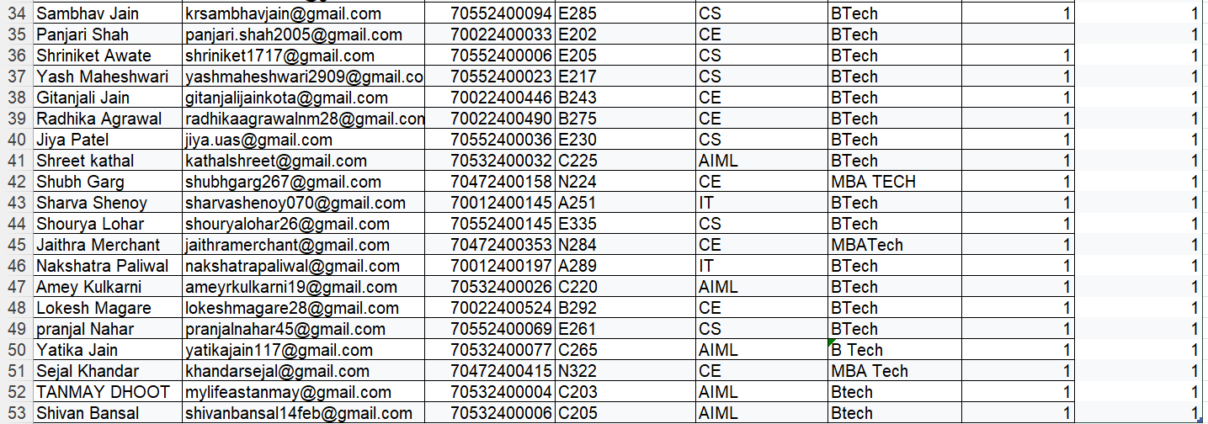

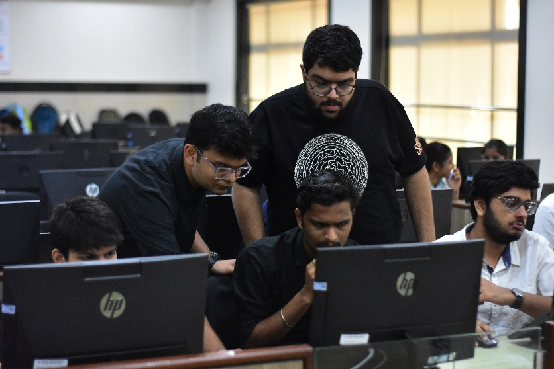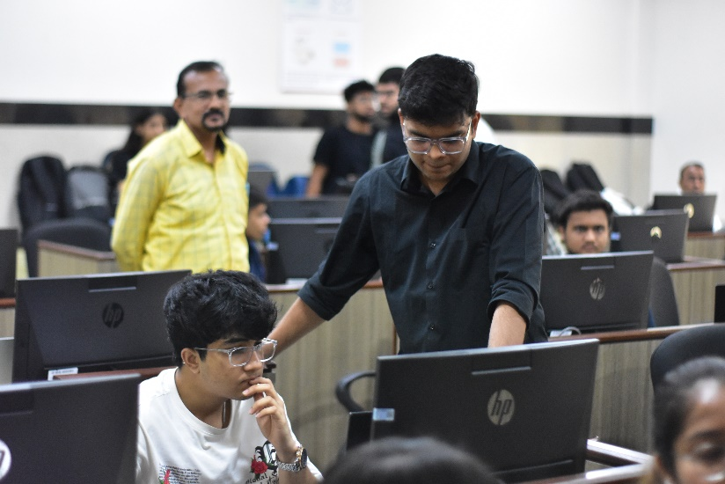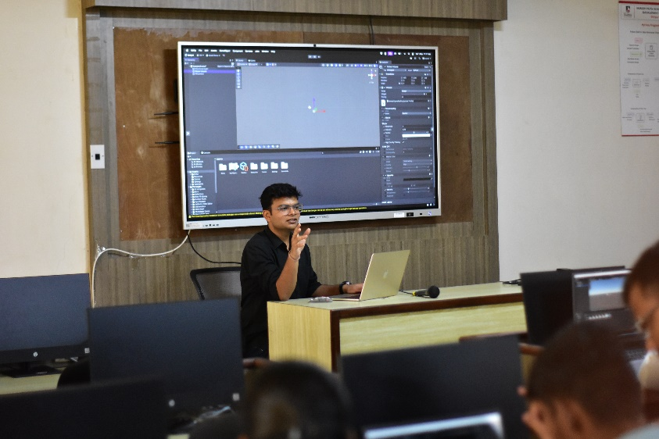**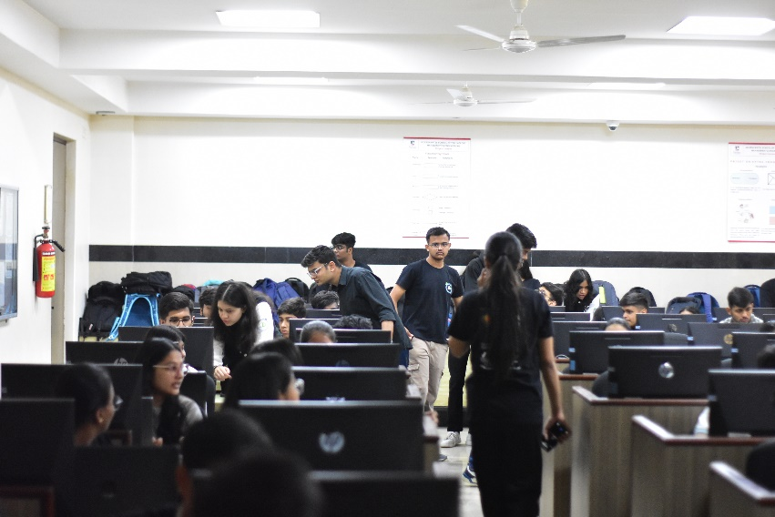Snaps**:-

Asst. Prof Dhiraj Bhise

Event In-charge HOD Associate Dean